1. Take db dump.

Login with the SSH for the server.

sudo ssh -i jitsi_openfire.pem ubuntu@

>> sudo su postgres

>> psql

Take db dump:

pg_dump -F c openfire_4_6_2 > openfire_4_6_2.sql

pg_dump -Fc -h 127.0.0.1 -U openfire openfire_4_6_2 > openfire_4_6_2.sql

1. Server Team create the new server.
2. Install and setup the database.

NOTE:

—-------------------------------------------------------------------------------------------------------------------

Java 1.8.0_342 private build

https://github.com/igniterealtime/Openfire/releases?page=2

Link address: <https://github.com/igniterealtime/Openfire/releases/download/v4.6.2/openfire_4.6.2_all.deb>

https://www.cometchat.com/tutorials/how-to-install-openfire-on-ubuntu

—-------------------------------------------------------------------------------------------------------------------

**Steps Done:**

Check the postgres version in old system:

psql --version

Install the postgresql <https://computingforgeeks.com/install-postgresql-12-on-ubuntu/#google_vignette>

CREATE DATABASE openfire_4_6_2;

CREATE USER openfire WITH ENCRYPTED PASSWORD 'gvVXrKycjNWm7sm';

GRANT ALL PRIVILEGES ON DATABASE openfire_4_6_2 to openfire;

Copy data base from the local to remote db

sudo scp -i jitsi_openfire.pem openfire_4_6_2.sql ubuntu@34.204.1.20:/home/ubuntu

>> cd /etc/postgresql/12/main

>> sudo nano pg_hba.conf

Add the below rules

# Database administrative login by Unix domain socket

local all postgres peer

local all openfire trust

>> sudo systemctl restart postgresql.service

>> systemctl restart postgresql@12-main.service

Import the database sql file in the postgres database

>> pg_restore -U openfire -d openfire_4_6_2 < openfire_4_6_2.sql

**Check both the database files:**

postgresql.conf

pg_hba.conf

1. Install the openfire

<https://www.cometchat.com/tutorials/how-to-install-openfire-on-ubuntu>

>> curl -L <https://github.com/igniterealtime/Openfire/releases/download/v4.6.2/openfire_4.6.2_all.deb> -o [openfire_4.6.2_all.deb](https://github.com/igniterealtime/Openfire/releases/download/v4.6.2/openfire_4.6.2_all.deb)

>> sudo apt install ./openfire_4.6.2_all.deb openjdk-8-jre

# original version

sudo apt install ./openfire.deb openjdk-8-jre

#Latest Version

curl -L <https://github.com/igniterealtime/Openfire/releases/download/v4.7.5/openfire_4.7.5_all.deb> -o [openfire_4.7.5_all.deb](https://github.com/igniterealtime/Openfire/releases/download/v4.7.5/openfire_4.7.5_all.deb)

>> sudo apt install ./[openfire_4.7.5_all.deb](https://github.com/igniterealtime/Openfire/releases/download/v4.7.5/openfire_4.7.5_all.deb) openjdk-8-jre

openfire.gatherhall.com

jdbc:postgresql://3.216.12.149:5432/openfire_4_6_2

jdbc:postgresql://localhost:5432/openfire_4_6_2

openfire

gvVXrKycjNWm7sm

200 350

==========================================================

chat.gatherhall.com

jdbc:postgresql://gotochat-openfire.cwuud6wgdvez.us-east-1.rds.amazonaws.com:5432/openfire

openfire

gvVXrKycjNWm7sm

200 350

1. **Move all the Data and Configs:**

>> sudo apt-get install unzip

Copy zip file to /home/ubuntu

>> unzip zipfilename.zip

Move /etc/openfire:

Certificates_GatherHall.p12

Gatherhall_VOIP.p12

Certificates_GatherHall.p8

openfire.xml.save

openfire.xml.save.2

openfire.xml.save.1

openfire.xml.save.3

roomqrcodes/

available-plugins.xml

server-update.xml

Move /home/ubuntu:

Complete Folder

Move /usr/share:

Create tar file command:

tar -czvf filename.tar.gz /path/to/dir1

Uninstall openfire:

**sudo /etc/init.d/openfire stop**

**sudo update-rc.d -f openfire remove**

**sudo rm /etc/init.d/openfire**

**sudo rm -rf /opt/openfire**

**sudo rm -rf /usr/share/openfire**

**sudo apt-get --purge remove openfire**

Start service

**sudo /etc/init.d/openfire start**

**adminConsole.access.allow-wildcards-in-excludes= true**

Count the number of file in the folder:

ls -1 | wc -l

1. \? list all the commands
2. \l list databases
3. \conninfo display information about current connection
4. \c [DBNAME] connect to new database, e.g., \c template1
5. \dt list tables of the public schema
6. \dt <schema-name>.* list tables of certain schema, e.g., \dt public.*
7. \dt *.* list tables of all schemas
8. Then you can run SQL statements, e.g., SELECT * FROM my_table;(Note: a statement must be terminated with semicolon ;)
9. \q quit psql

￼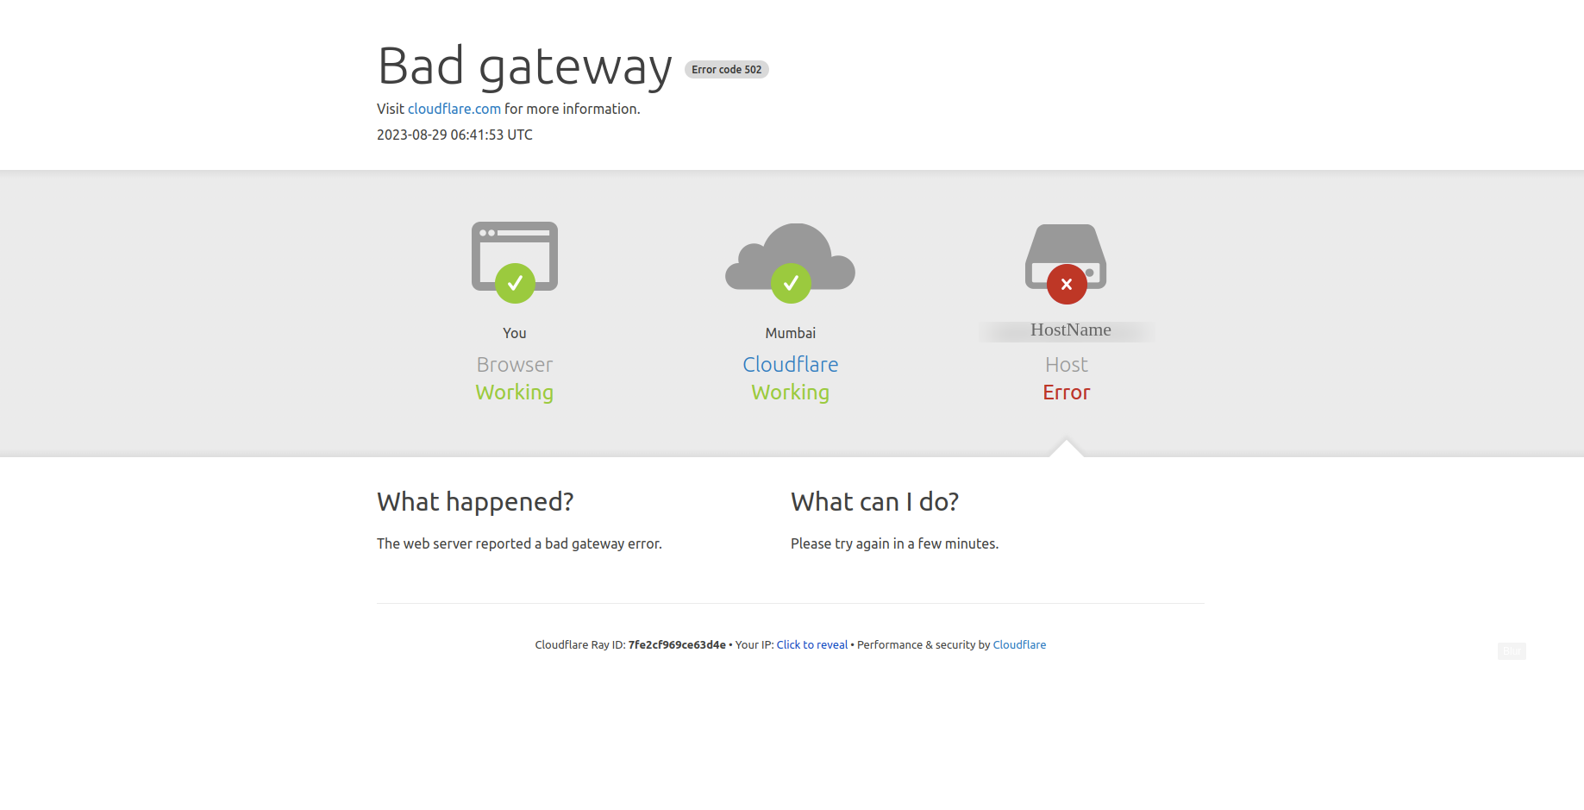

LIb’s Need to Copy in new openfire setup:

Apache-jsp-9.4.43.v20210629.jar

**Change the Domain name:**

SELECT name, propValue FROM openfire.dbo.ofProperty WHERE name = 'admin.authorizedJIDs' OR name = 'xmpp.domain'

Stop Openfire.

Edit conf/openfire.xml in your Openfire installation folder and set <setup>true</setup> to <setup>false</setup>.

Restart Openfire and enter the setup tool.

=======================================================

netstat -ntlp | grep LISTEN

chmod g-w roomqrcodes/

chmod g-w roomqrcodes/

or

Sudo chmod +777 -R /usr/share/openfire/conf/roomqrcodes

Sudo chmod +777 -R /etc/openfire/roomqrcodes

tar -czvf roomqrcodes.tar.gz /usr/share/openfire/conf/roomqrcodes

====================================================================

Add Cron tab

>> crontab -e

Select the option 1

* * * * * /home/ubuntu/auto_start_service.sh

auto_restart_cron